



[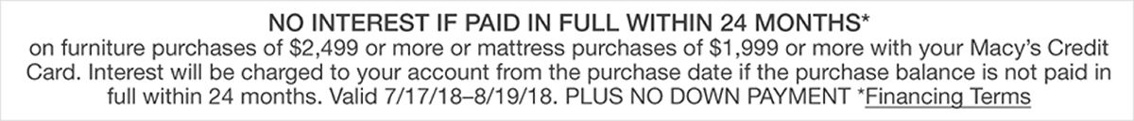](javascript:pop('/popup.ognc?popupID=847038','myDynaPop','scrollbars,width=365,height=600'))

TAX FREE WEEKEND AUGUST 11TH AND 12TH

