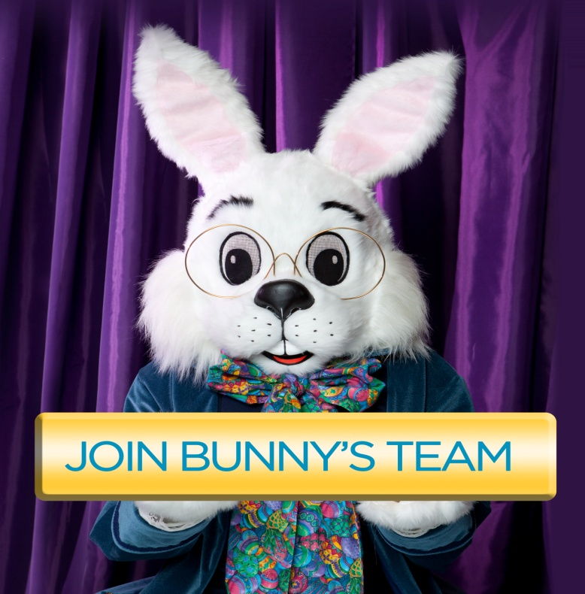

If you are looking for a **FUN** seasonal job we have a great opportunity for you.

Cherry Hill Programs is seeking talented, enthusiastic and dedicated people to deliver magical experiences for Bunny's guests!

**We are looking for managers, sales associates and furry characters to work at local malls in the area.**

If interested in joining our inspired team please go online to search for your mall or state at [www.CherryHillPrograms.com](https://l.facebook.com/l.php?u=http%3A%2F%2Fwww.CherryHillPrograms.com%2F&h=ATOZGrC9JEe1hFCqfmMf3hEFUzggJPaOLgj0g15KRAZZsVujveauGeWMTBKLLM4y71FZb_osWkwc5kCxODPJ90Kb__b-Tn_nOX0nhHmwjrU7U9N3ZRpcd7tWOKe48qlm3G_yDkTDMpaFGa7Ai9FVSTVV4Ztff9AzKpO0ztCaaB60zZckmeC2fB4fI0bILwfAhAxA_ZWulDVFA91OAziWFVa2tHhGpU0Pa7em3L-x57GAmGnNtn57-EDOk2pKjAD0fcQ79qmMniGOt5a8ik1LnTgBWGFouGsibsrAiIpi0A) today!

