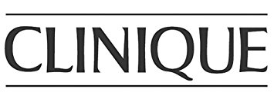

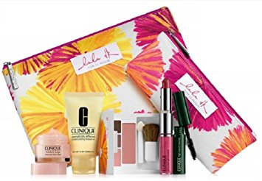
Clinique Makeup Bag Exchange – at Lord and Taylor 8/17-8/27

Make an appointment at the Clinique counter TODAY!

- Make an appointment at Clinique
- Bring in your old makeup bag with all of your makeup products
- Pick out a new makeup bag*
- Get a free mini makeover and a Clinique Sample

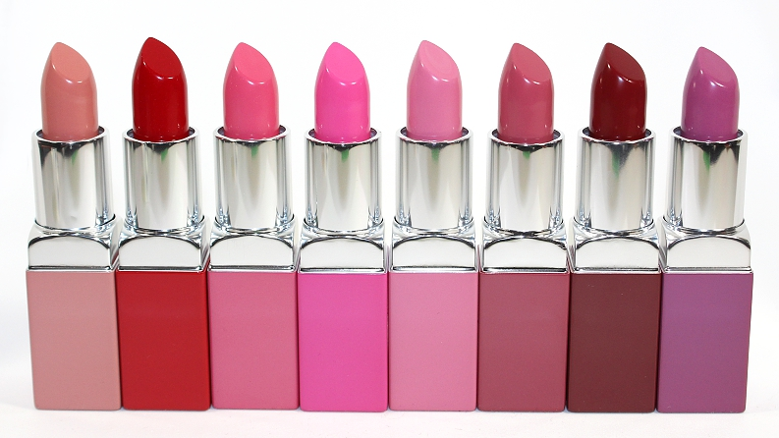

*While supplies last

