[](http://www.bing.com/images/search?view=detailV2&ccid=n/LBh3JG&id=394BB4FC9B90A4EEAF82A044F406474A6C6561BE&thid=OIP.n_LBh3JGXQ1DQsgJ989LIQEsBk&q=le+vian+logo&simid=608013739595795450&selectedIndex=10)[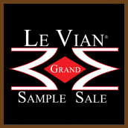](https://www.macys.com/shop/jewelry-watches/le-vian/Special_offers/Clearance/Closeout?id=65939&cm_sp=c2_1111US_browse_jewelry-%26-watches-jewelry-brands-le-vian-_-row5-_-icon_clearance-%26-closeout)

# One Day Only!

Le Vian Extravaganza

## Le Vian Trunk Show & Grand Sample Sale

One Day Only: **Tuesday**, **October 30th, 2018**   
**10 a.m – 6 p.m**   
***Only at Macy’s Walden Galleria***  4 Walden Galleria Dr.

To Book an Appointment: 716-684-6267 extension 568

You are invited to a rare opportunity to see our latest creations of unique, one-of-a-kind designs never before seen in store! To celebrate Le Vian Day, we are offering exclusive handmade Le Vian Couture designs in limited quantities at unheard of day-of-show pricing.

All Le Vian pieces come with a certificate of authenticity.

Le Vian is one of the highest quality pieces of jewelry, & all gems are hand cut.  
  
Unique designs that are exclusive to Le Vian and Grand Sample Sales

**Show Special: Nude Diamonds, Peach Morganite, and Strawberry Gold!** 



**To book an appointment:**

**716-684-6267 extension: 568**

* Vanilla Solitaries
* Pomegranate Garnet
* Raspberry Rhodolite
* Blueberry Tanzanite
* Neapolitan Opal
* Le Vian’s Crazy Collection



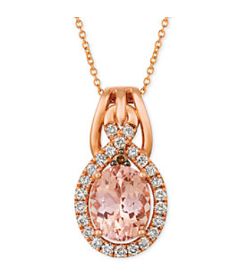

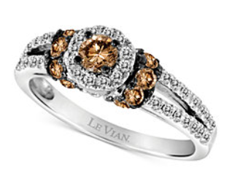

**To book an appointment:**

**716-684-6267 extension: 568**