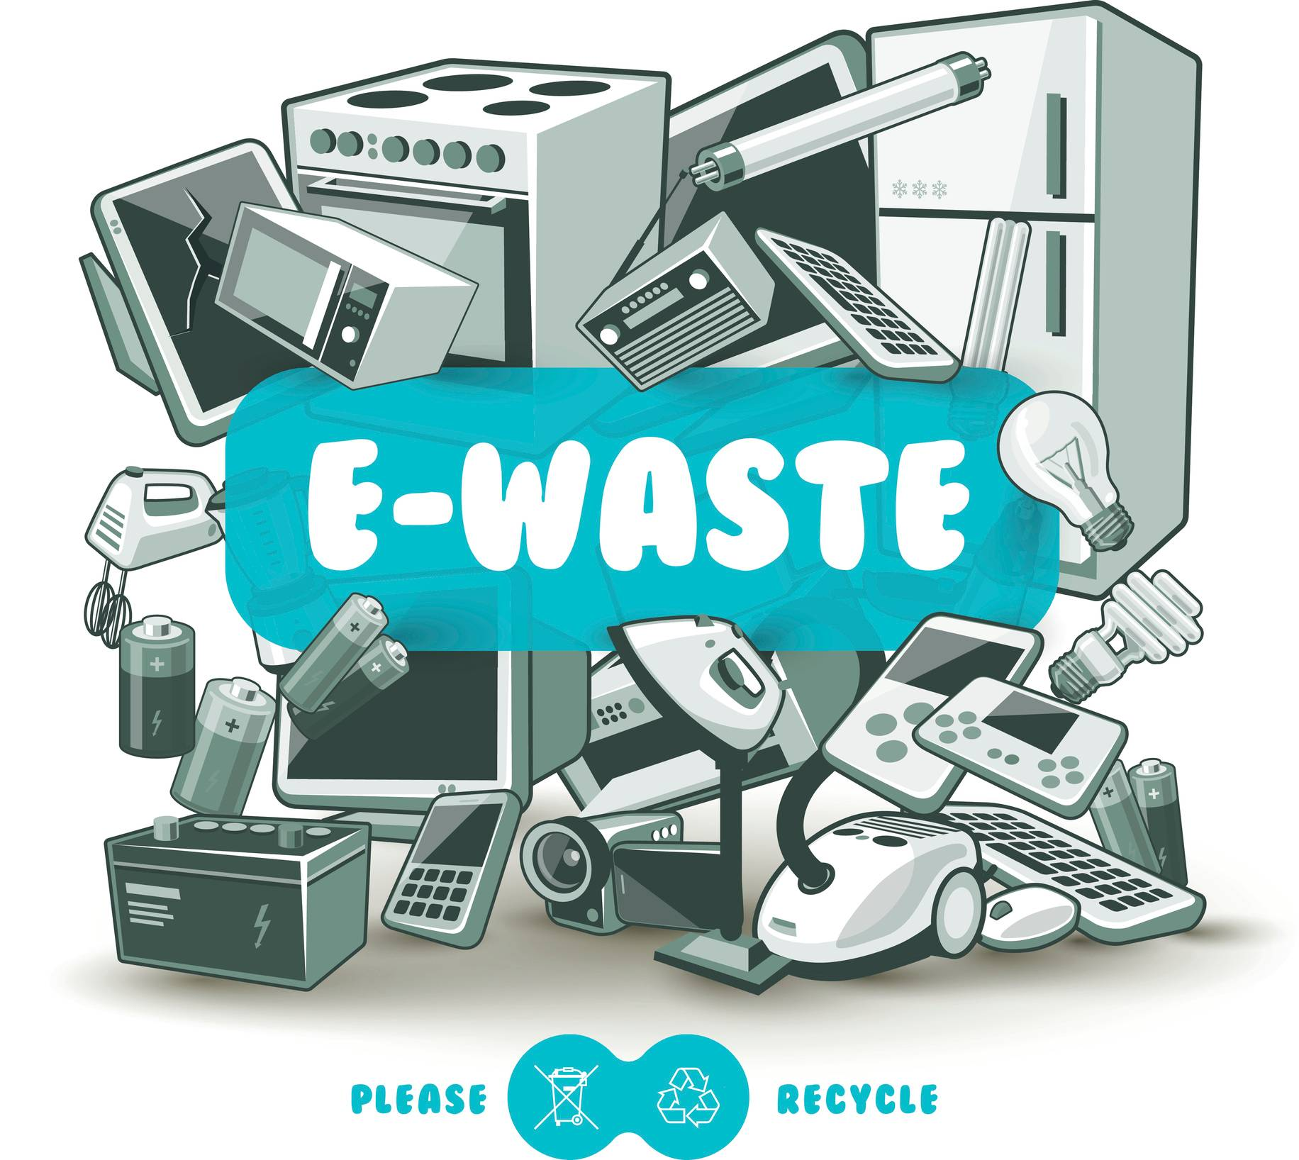 | Free E-Waste Event
When: June 20th 11 am – 2 PM
Where: Crossgates Mall
Adirondack Junkluggers is having a FREE E-Waste event at the crossgates mall. We would like for everyone to bring their old electronics they do not want/use to us and we will recycle everyhting we get.

The Junkluggers is far more than your average junk removal company. Since the founding in 2004, The Junkluggers franchise have kept their mission in mind, "To Enhance Lives, Our Community, and the Environment by Donating, Recycling, and Supporting Local Charities."

 | What to Bring:  Laptops  AC Units  TV (not CRT/Tube)  Cell Phones  VCR/DVR/DVD Player  Toasters, Coffee Maker, etc. | What not to Bring:  Monitors  Batteries  Lamps  Lightbulbs  Medical Equipment  Furniture  Washer/Dryers | Come support a local junk franchise trying to make a difference for our planet.
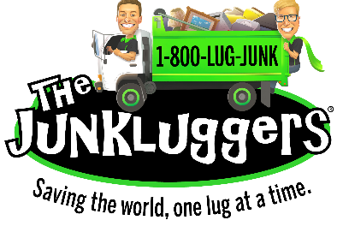
We do have the right to turn away products that are not accepted.

