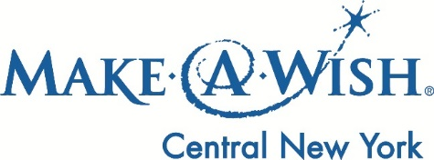

**Imperial Stout Tapping Party! Wednesday, May 24th from 6-8pm!**

We are proud to announce that we have joined forces with Recess Coffee to brew an Imperial Coffee Stout!

All proceeds from the keg donation and the silent auction table will benefit Make-A-Wish® Central New York. So don’t forget to stop by, drink some good beer and help a great cause!

