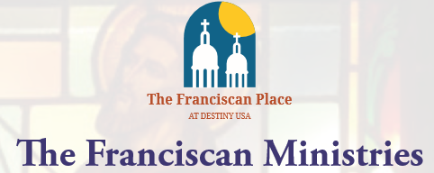

IN PARTNERSHIP WITH HOLY FAMILY CHURCH

PRESENTS A FREE EVENT:

RAISING FAITHFUL CHILDREN

TUESDAY, DECEMBER 5TH AT 7PM AT HOLY FAMILY CHURCH, 127 CHAPEL DR.

Ken Hensley is a nationally known Catholic teacher and author, who since converting to the Catholic faith in 1997 has taught extensively in the field of Catholic apologetics and biblical studies. We hope you will join us for this free event.